State Sleuths
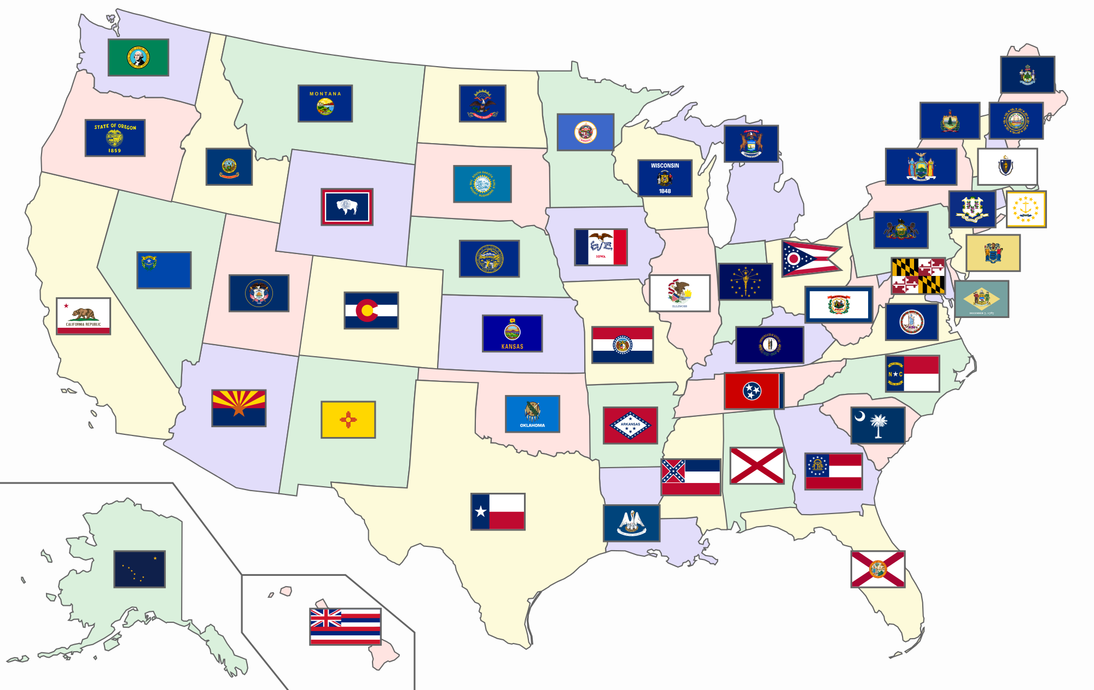
Open Safari.
Go to SC Discus.
Choose A-Z List.
Select C and then Culturegrams.
From dropdown, choose States Edition and select your state.

Directions:
1. Tell me two quick facts about your state.

2. What is the capital?

3. What is the state tree?

4. What was the name of one Native American tribe?

5. What is their main economic resource in this state?

6. Name a famous person from this state.

7. Draw a picture of the state’s flag.

Alaska | Wyoming
Kansas | Kentucky
Maine | Massachusetts
Florida | Illinois
California | Nevada
Nebraska | Washington
Oregon | Louisiana
Delaware | Connecticut
Pennsylvania | Iowa
Ohio | Montana

