Genius Hour with Discus
I have implemented a Genius hour program for our 6th and 7th graders. Genius hour is a movement that allows students to explore their own passions and encourages creativity in the classroom. It provides students a choice in what they learn during a set period of time during school.
Students are given an orientation to Genius Hour beginning with a video presentation.
During the orientation, I present the following resources for them to use for their Genius Hour projects:

- Video presentation explaining Genius Hour
- Project proposal
- Project Planning
- Research steps - BIG 6
- Discus- I introduce them to the SCDiscus.org website, the different databases, and tools they can use such as: citation, saving to Google drive, and audio of the articles. I also give them the Discus bookmarks so they will have the logins for when they are at home.
- Presentation Menu
- Different tech resources they can use for their projects

I have a Symbaloo that I use for the presentation and I post the Symbaloo in Google Classroom for the students to use during the project. At the bottom of the Symbaloo, I have included resources for the teachers who want to learn more about Genius Hour. I also put together a packet for each teacher which includes: handouts and rubrics (including a handout for the Discus Scavenger Hunt for Middle School), a Discus bookmark, a Big 6 info card, a Discus pen, and the Google Classroom code.

Genius Hour Presentation Menu
*Choose one of these ways to show what you learned! Bring it to class to show us by the end of the month!
Write a Research Paper This should be a 5 paragraph essay about what you learned. Don’t forget your introduction and conclusion! | Make a Google Slides Presentation You can use your school email account. Share it with your teacher! | Make a Poster  Make sure you include pictures and lots of information on your topic!
Make a Model  Show what you learned by making a model of your topic. Make sure you include labels! | Make a Video  Show what you know by making a video. It must give viewers plenty of information! | Create a Board Game  Make a board game that helps others to learn about your topic!
Make a Mobile  Include pictures and information as well as a great decoration to hang from your ceiling! | Be the Teacher  Make a test about your topic that would show you that others understand your information! | Create a Museum Exhibit Make sure it is small enough to come to school with you!

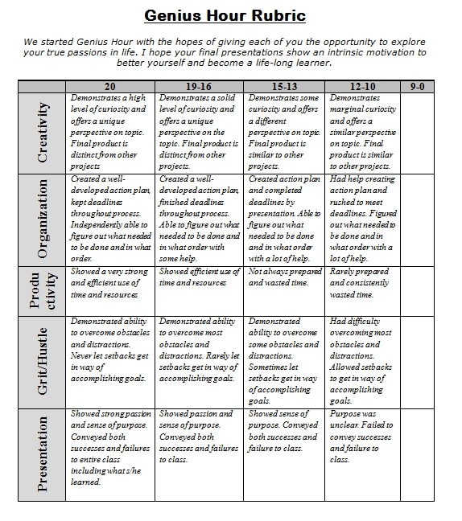
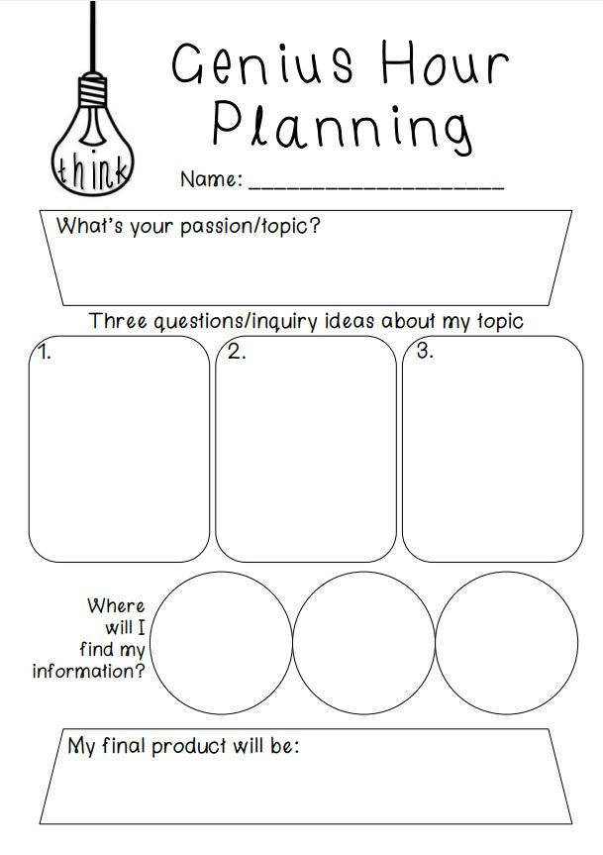
Genius Hour Project Proposal
- What is your proposal topic?

- What are the top 3 inquiry-based questions you brainstormed about you topic?

- Why are these questions important to you?

- What do you hope to learn?

- How do you plan to share your project with others?

- What materials will you need?

- List some ways that I can support you and your project.

